Flygility Course Design

Guidance for Judges

Introduction
This document is intended to give guidance to Judges who are designing Flygility courses for competitions. The main aim is to ensure that there is a consistent interpretation of the rules and to provide a repository for lessons learnt.

Beginners
The rules at this level leave little room for misinterpretation. Although the degree of difficulty can be increased by the inclusion of the long jump or by using wings, it should be borne in mind that at this level these are often beginners to the sport we are trying to encourage the dogs’ confidence by making it as easy as possible. Probably more appropriate to leave increasing the difficulty to the higher levels.

Intermediate
As with Beginners, the rules at this level leave little room for misinterpretation. A bend is allowed in the course by way of a tunnel and the ramp may be used. Given that there is such a huge jump between Intermediate and Senior it may be useful to make courses slightly more difficult occasionally, which could be by done by the use of wings on some jumps or the long jump.

Senior

Use of Weaves
There is a huge jump in the level of difficulty when weaves are introduced into a course. Many dogs struggle with weaves at the best of times and the jump from Intermediate to Senior is also a big one. So in order to reduce this, the obstacles immediately prior to and after the weaves should be in-line with the weaves i.e. don’t use the weaves to initiate a change of direction.

Advanced
When designing an advanced level course, judges should remember that Flygility is about racing with challenges, not a competition to see whose dog can do the most complicated course. Competitions where the courses are so difficult that they create endless reruns are not enjoyable for the competitors or spectators.

Course Flow
At this level it is possible to create courses that can meander all over the place and still be within the rules. Courses should flow from one end of the course to the other. The direction of travel for the dog should not be greater than 90° from the direction of travel.
The use of the serpentine is one example where the direction of travel for the dog can easily be greater than 90° and could approach 180°. It is for this reason that the line of jumps in the serpentine should not deviate from the direction of flow by more than 60° (referring to a clock face, running from 6 towards 12, the change should not be greater than turning right to 2 or left to 10).
Another example is the use of tunnels in a course (see below).

Examples Using Serpentine Jumps
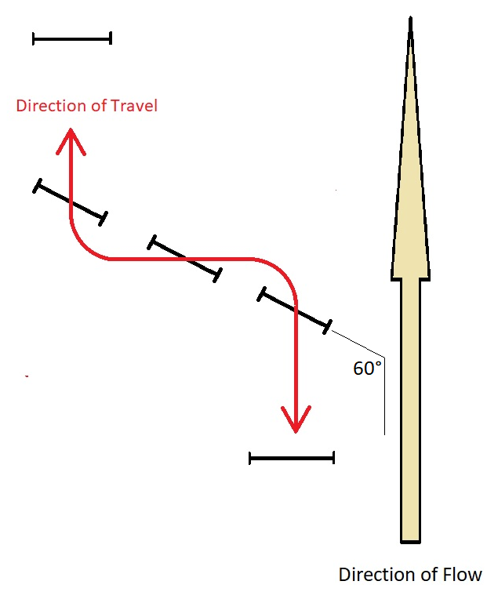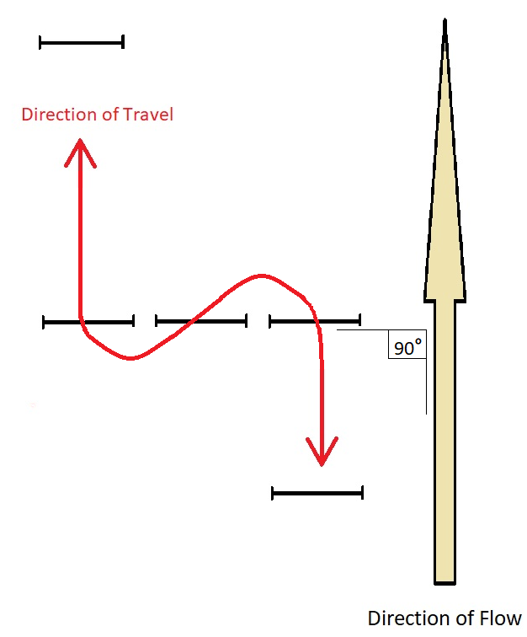
Good Bad
Examples Using Tunnels
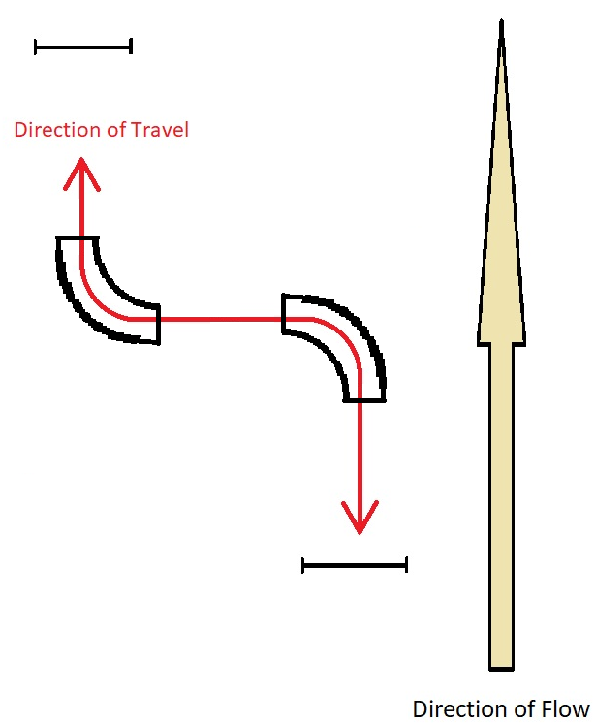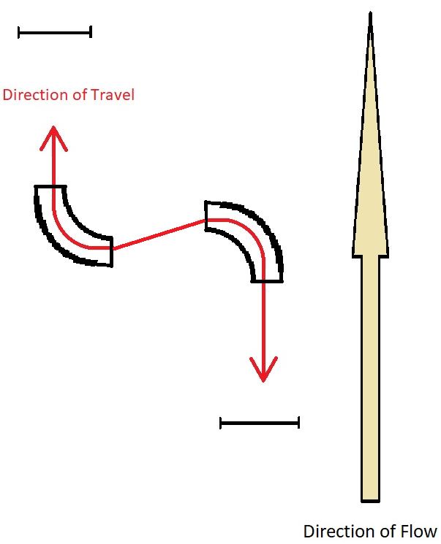
Good Bad
The examples above are just that, and the principle of ensuring that the direction of flow is maintained should be applied across the use of all equipment types.

Dog Size
When designing a course Judges should take into consideration how different sizes of dogs will be able to manage obstacles within it. One of the primary concerns here is the safety of the dogs. For example a sharp turn into the ramps may be perfectly safe for smaller dogs, but for larger dogs this may lead to them slipping off the ramp, which is a safety hazard.
One option may be that where the Judge knows that there will be splits in an event the course could be adapted for each height.

Definitions

Direction of Flow
The direction of flow is a line running parallel to the sides of the course from the start/finish line to the flybox end and back again.

Direction of Travel
This is the direction that the dog will be expected to travel when negotiating the course.

Changes of Direction
What constitutes a change of direction has often been a source of confusion, particularly where that change has been managed through a bend. A change of direction can be accomplished by angling a piece of equipment, using a series of jumps in an arc, or by offsetting equipment. Below are several examples of courses that illustrate what constitutes a change of direction.
1
1
2
1 Change of Direction 2 Changes of Direction

3
2
1
1
3
4
2
3 Changes of Direction 4 Changes of Direction

